Thank You!

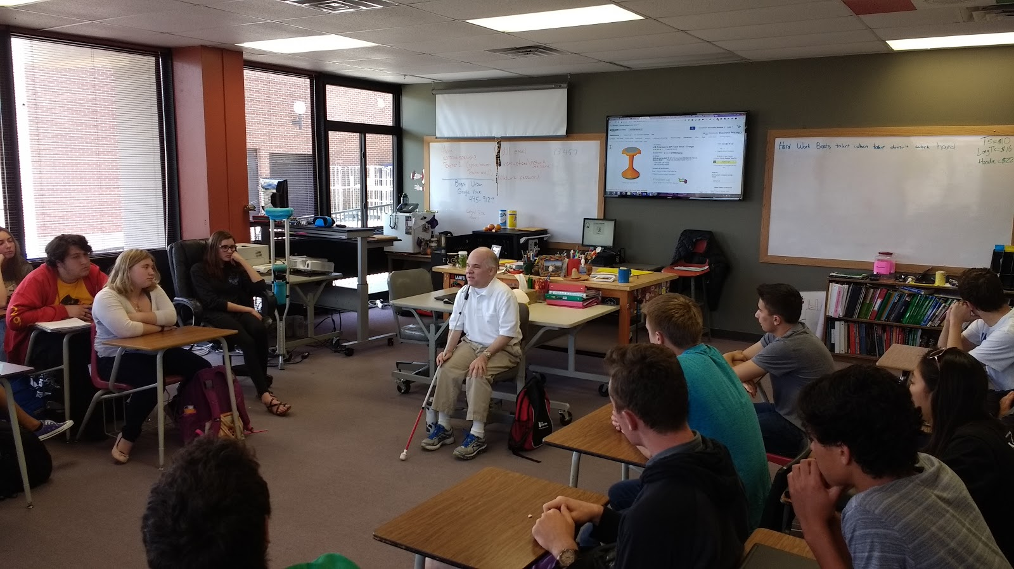

Matthew, Thanks so much for volunteering your time with students. I truly appreciate all of your wisdom and generosity. You are kind, wise and have been and great resource for us.

Thanks so much!

Brent
( I included a picture of you speaking in case you might want to use it)

Dear Dr. Weed,

Thank you so much for coming, it meant a lot to me. I especially appreciated all of your advice about going to a college a long way from home and how to deal with that. I think that it will help me as I go into the world and try to make my mark in Portland and have a good time!

Sincerely, Luke

Dr. Matthew Weed,

Thank you so much for coming in to talk to us. Lately I have been struggling and worrying about college as I am a junior and I am starting to look more into my future. You were very helpful.

Cami

Dear Dr. Weed,
I would like to thank you for coming to our Spanish class and offering some much needed college advice. Even though we haven’t gone through the same struggles, you certainly know what it’s like to have to adjust to an entirely new environment. I am very grateful that you were completely honest with our class, as opposed to give us what we want to hear. Your advice will help me tailor my college experience to what works best for me.

Thanks again,
Holly

Dr. Weed,

Thank you for taking your own time to share advice to us students. Personally helpful questions of which I wouldn’t have thought were answered by you for other students, and the hour did help me to consider my plans for university.

David

Dear Dr. Weed,

Thank you for joining our class and helping us prepare for our next stage of life in college. I have been worrying about how to build relationships with my professors since there is not as much face to face time, and your answer to my question relieved a ton of my stress. Listening to your life story was fascinating and one day I hope to accomplish a fraction of what you have done.

Sincerely,
Clay

Dr. Matthew Weed,
Thank you so much for taking time for coming to our school and talking to us about college. I really enjoyed hearing your story and your experience in college, hearing what you have achieve and what have done was incredible. I had learned a lot from your visit and has helped me prepare for college, how to manage my time and how to meet new people. Thanks again for coming down and taking your time to answer our questions we had about college.

Sincerely,
Haley

Dr. Weed,

Thanks for taking the time to come and speak to our class about college. Your advice and knowledge helped broaden my perspective on my options and helped me consider paths I didn’t think of before. I very much liked your perspective on research both in and out of academia and your elaborations on the cultures of ivy-league schools. Thank you very much for coming in and talking to us high-schoolers, and helping us to understand the intricacies of college.

Ryan

Dr. Weed,

Thank you so much for coming to speak to us about our futures in college. Your advice is greatly appreciated as I go into my senior year and decide on a college.
Maya
Dr. Weed,

I am so thankful for the opportunity to be able to gain advice from you on the near future. Your advice on healthy relationships with professors will be very helpful and I hope to be as dedicated as you throughout my life. You are a genuine person, and very kind. Thank you for your useful information and I wish you the best in your next endeavor.

Sincerely,
Cassie Lewis

Dr. Weed,
Thank you so much for coming in and speaking with our class. It is very much appreciated, and your information and question answer time helped to answer a lot of my questions for my future. I now feel more prepared and confident on how to establish relationships within college which is very important for the major I intend to pursue, and I now know that these relationships are one of the greatest resources one can have in college. Thank you again!
Sincerely,
Hannah

Dr. Weed,
Your advice to us yesterday was some of the most helpful I have received in all my college-searching process. You helped me understand some things I had never thought about concerning my college career, and I think the lessons you gave will prove to be quite prevalent throughout my 4+ years of study to come. Thank you very much for imparting your knowledge, I’m glad I got this wonderful chance.
Jacob

Dear Dr. Matthew Weed,

Thank you for taking the time to come in to discuss college, being that college is challenging but that with your help, college can be fun and not as difficult as it may be.
-Benito

Dear Dr. Weed,
Thank you so much for coming in to speak to our class yesterday. As a student going into college this year, I was really worried about going into college, given that it is a very different environment from high school. However, with your advice on who to build relationships with and how, and even telling a trick on how to get more aid, I feel more confident and less worried about going into college. I am really thankful for your advice. Thank you so much!
-Jeanine

Dr. Weed,

Thank you for taking coming in to speak with our class yesterday. As a senior going into college, everything you answered and assisted us with was an immense help. I appreciate all the advice! Thank you again!

-Taryn

Dear Dr. Weed,
Thank you so much for giving us the opportunity to speak with you. I learned a lot from you and i think i am significantly more prepared for college because of the advice that you gave us. I had no idea that relationships with faculty was so important! I wish you the best of luck in your future, and all that you have accomplished has inspired me to do so much more.

Dear Dr. Weed,
Thank you so much for coming to my class and telling us about how you have gone through your continuing education. I am at the point in my life where I am trying to make the decision on what I am going to do with my life, and your presentation, specifically when you suggested looking at faculty to student ratios and graduation rates, have helped me in deciding where I am going to go to college.
-Natalie

Dear Dr. Weed
Thank you so much for taking the time to come to our school and help us understand collage. I deeply enjoyed hearing about your life and how you got to the place you are now. I feel more prepared for college now that i have talked to you. I had never thought about looking at the stats of the graduates before you told me. I will be looking at those now thank you. I also would like to thank you for telling me to make relationships with the adults at my school of choice. I have probably said it ten times already but once again thank you
-Gabrielle

A note from Dr. Weed, I can connect you with this teacher if you are a teacher and wish to speak with him as a reference.

